**NNAMDI AZIKWE UNIVERSITY, AWKA**

**DEPARTMENT OF COMPUTER SCIENCE**

**THREE MONTHS REPORT ON STUDENTS INDUSTRIAL WORK EXPERIENCE SCHEME (SIWES)**

**AT**

**LINAS INDUSTRIES LTD, ONITSHA**

**NNUBIA NZUBE IKECHUKWU**

**2017514129**

**SIWES SUPERVISOR**

**SUBMUTTED IN PARTIAL FULFILMENT OF THE REQUIREMENTS FOR THE AWARD OF BACHELOR OF SCIENCE (B.Sc) DEGREE, IN THE FACULTY OF PHYSICAL SCIENCE, NNAMDI AZIKWE UNIVERSITY AWKA.**

**DEDICATION**

This report is dedicated foremost to God almighty for his favour, mercy and grace upon my life especially during my months of SIWES programme.

I would also like to dedicate it to my parents and siblings for their love and support and everyone else that contribute towards making my SIWES training a fun and successful one.

**ACKNOWLEDGEMENT**

My appreciation goes to the Siwes coordinators for their foresight in putting this program in place.

I am also grateful to Linas solution for providing me with necessary skills to be exposed in my field. I also want to say a big thank you to all my able colleagues for making my stay at cheche a blissful one.

To my parents and siblings thank you for your moral and financial support.

I am deeply indebted to God Almighty, the giver of all wisdom, knowledge and understanding, without whom I could have achieved nothing.

**ABSTRACT**

This industrial report presents the experience gained during my three months of industrial training.

My training was on web development.

I acquired practical knowledge on how to develop a web application and how to develop API (application program interface) and database for it.

This report discusses the technical skills gained during the training period and justifying the relevance of the scheme in equipping students with needed technical competence to thrive in our today society.

**TABLE OF CONTENTS**

**Title Page**

Dedication……………………………………………………………………….1

Acknowledgement……………………………………………………………….2

Abstract…………………………………………………………………………..3

Table of Contents…………………………………………………………………4

**Chapter 1**

**Introduction**……………………………………………………………………….5

Purpose of Training………………………………………………………………..

Background of SIWES…………………………………………………………….

Aims and Objectives of SIWES…………………………………………………...

Benefits of Industrial Training…………………………………………………….

Company Vision…………………………………………………………………..

Company Area of Specialization………………………………………………….

**Chapter 2**

**Industrial Experience**……………………………………………………………

Definition of Terms……………………………………………………………….

HTML and its properties…………………………………………………………..

CSS / S(CSS) and its properties…………………………………………………..

Web Design using Html and CSS…………………………………………………

Javascript and its properties……………………………………………………….

Frontend using React js……………………………………………………………

Server-side Javascript……………………………………………………………..

Database and its Properties…………………………………………………………

Mongodb (NoSql)…………………………………………………………………..

**Chapter 1**

**Introduction**

1. **PURPOSE OF TRAINING**

The student industrial work experience scheme (SIWES) popularly called Industrial Training (IT) by Nigerian Students is a yearly program design by the institution in collaboration with the industries to give students the opportunity to gain practical experience in their various field of study or area of specialization. It is an effort to bridge the existing gap between classroom theories and practical’s in engineering, management and other professional programs in the Nigerian tertiary institutions.

Training is the key factor in changing expertise of a workforce. The world is passing through one of the worst economic crises in recent time. Both the developed and developing economics are experiencing serious economic downturns.

It is through this industrial training that the educational systems aims at helping students acquire appropriate skills, abilities and competences, both mental and physical as well as equip the individual to live in society. The focus of the Industrial Training Fund (ITF) is for the industries of our countries to succeed in the face of the current economic meltdown.

No society can achieve meaningful progress without encouraging its youth to acquire necessary practical skills. Such skills enable them to harness available resources to meet the needs of the society.

* 1. **BACKGROUND OF SIWES**

Before the establishment of the scheme, there was a growing concern that graduates of institutions of higher learning lacked adequate practical knowledge and that the theoretical education in higher institutions was not responsive to the needs of the employers of labor.

As a result of this, the Industrial Training Fund (ITF) was initiated, designed and introduced SIWES Scheme in 1973 to acquaint students with the skills of handling equipment and machinery.

The students Industrial Work Experience Scheme (SIWES) is a skill training program designed to prepare and expose students of universities, polytechnics, colleges of education etc. for the industrial work experience they are likely to meet after graduation.

The Industrial Training Fund (ITF) solely funded the scheme during its formative years. However, due to financial constraints, the fund withdrew from the scheme in 1978. The federal government noting the significance of the skills training handed the management of the scheme to its National Universities Commission (NUC) and the National Board for Technical Education (NBTE) in 1979. In November, 1984 management and implementation of the scheme was again reverted to ITF with the funding to solely borne by the federal government.

* 1. **AIMS AND OBJECTIVES OF SIWES**

The specific objective of SIWES were summarized by the federal government as follows is meant to ensure.

* Provide adequate skill acquisition for tertiary institution students
* It is designed to give these students an idea of real work situations and experience they are likely to encounter after graduation.
* They also include providing a structural attachment program with emphasis applications, management and hands-on experience for students to apply knowledge acquired.
* Advanced countries, with over 100 years of sustained industrial development and requisite technical and human infrastructure, have been able to adequately implement training for their students.
* Moreover, it helps them to gain interpersonal and entrepreneurship skills and also instill in them the right kind of work altitudes and professionalism through interactions with peoples in the organization and observation of their future role in the industry.
  1. **BENEFITS OF INDUSTRIAL TRAINING**
* Provide avenue for students in institution of higher learning to acquire industrial skills and experience in their course of study.
* Provide students with an opportunity to apply their knowledge in real work situation thereby bridging the gap between theory and practical
* Makes the transition from school to the world of work easier and enhance students contact for later job placement.
* Expose students to work methods and techniques in handling equipment and machinery that may not be available in their institutions;
* Enlist and strengthen employers’ involvement in the entire educational process and prepare students for employment after graduation.

The major benefits accruing to students who participate conscientiously in industrial are the skills and competencies they acquire. These relevant production skills (RPSs) remain a part of the recipient of industrial training as lifelong assets which cannot be taken from them. This is because the knowledge and skills acquired through training are internalized and become relevant when required to perform jobs or functions. Several other benefits can accrue to students who participate in industrial training.

* 1. **COMPANY VISION**

Linas IT solution is a tech company dedicated to customer satisfaction. our combined experience spans almost a decade and we are able to solve all your tech problems ranging from hardware to software issues. because we love this business as much as you do.

* 1. **COMPANY AREA OF SPECIALIZATION**

With a team of software developers and IT personnel with a sound experience in software development. The company offer the various services such as mobile development, web development, software development, database management, internet and E-mail services.

**Chapter 2**

**Industrial experience**

1. **Definition of Terms**

The following are terms that are used in this department

**Website:**

A website is a set of related webpages containing contents such as texts, images, videos, audios. Etc. A website is hosted on at least one web server, accessible via a network such as the internet or a private LAN through an internet address known as a url (Universal Resource locator). A public accessible web sites constitutes the world wide web (WWW).

**Web page:**

A web page is a document typically written in plain text interspersed with formatting instructions of hypertext markup language (HTML, XHTML). A webpage may incorporate elements from other websites with suitable anchors. Webpages are accessed and transported with the hyertext transfer protocol (HTTP), which may occasionally employ encryption (HTTP secure, HTTP) to provide security and privacy for the use of the webpage content. The user’s application often a web browser renders the page content according to its HTML mark-up instructions into a display terminal.

**Web Application:**

A web application is application software that runs on a web server, unlike computer-based software programs that are run locally on the operating system of the device. Web applications are accessed by the user through a web browser with an active network connection. Its frontend is usually created using languages like html, css and popular frameworks and library in Javascript eg react, angular, vanilla, vue, svelte etc. while the backend will use any programming stack like LAMP, MERN or MEAN.

**HTTP:**

This stands for Hyper Text Transfer Protocol which is the set of rules for transferring files (text, graphic, images, sound, video and other multi media files on the World Wide Web.

**URL:**

This stand for Uniform Resource Locator and as the name suggests. It provides a way to locate a resource on the web, the hypertext system that operates over the internet.

* 1. **HTML and Its Properties**

HTML stands for Hypertext Mark-up Language and it is most widely used language to write web page.

* **Hypertext:** this refer to the way in which web pages (HTML documents) are linked together. Thus, the link available on a webpage is called Hypertext.
* As its name suggests. HTML is a markup language which means you use HTML to simply “mark-up” a text document with tags that tell a Web Browser how to structure it to display.

Originally HTML was developed with the intent of defining the structure of documents like heading, paragraphs, lists and so forth to facilitate the sharing of scientific knowledge between researchers.

Now, HTML is being widely used to format web pages with the help of different tags available in HTML language. With the popular version of html which is html5 it becomes easy for developers to build web pages

* + 1. **HTML TAGS**

As told earlier, HTML is a markup language and makes use of various tags to format the content. These tags are enclosed within angle braces <**Tag Name></Tag Name>**  this tags has a corresponding closing tag**,** except few tags that are self-closing tags **<Tag />**

The following are some basic html/html5 tags and their description

|  |  |
| --- | --- |
| Tag | Description |
| <html> | This tag encloses the complete HTML document and mainly comprises of document header which is represented by <head>…. </head> and document body which is represented by <body>…</body> tags |
| <head /> | This tag represents the document’s header which can keep other HTML tags like <title>, <link>, <script defer src=”index.js”/> |
| <title> | The <title> tag is used inside the <head> tag to mention the document title. |
| <body> | This tag represents the document body which keeps other HTML tags like <h1>, <div>, <p>, <table> etc. |
| <h1>, <h2>, <h3>, <h4>, <h5>, <h6> | This tags represent the heading tags, each tag has a different font-size. |
| <p> | This tag represents a paragraph |
| <br/>, <li>, <ol>, <ul> | Line break, list, ordered list, unordered list |

Well, there are lots of tags in html5 which are called semantic tags, some are for font-sizes e.g. <sup>, <em>, <strong>, <sub>, and some are meant for the layout e.g.<header>, <main>, <aside>, <section>, <figcaption>, <figure>, <img>, <div>, <footer> etc.

* 1. **CSS / S(CSS) AND ITS PROPERTIES**

CSS stands for cascading style sheets used for formatting text document. It is a style sheet language used for describing the presentation of a document written in a mark-up language.

* + 1. **Why CSS**

The following are reason why CSS is better

1. It saves time.
2. It provides the efficiency in design and updates with CSS, we were able to create rules and apply them on a web site.
3. it improves the look and feel of how web pages, thereby, generating traffic for the web page.
4. It is easier to interact with our client, due to the graphical user interface.

**2.2.1 Methods used by CSS in Formatting HTML Document**

1. **Inline Style:** it is used to apply a unique style to a single HTML element. An inline CSS uses the style attribute of an HTML element.
2. **Embedded / Internal Style:** it is used if one single page has a unique style. Internal style defined within the <style> element inside the <head> section of an Html page.
3. **External Style:** This is used to apply style to multiple HTML pages. With an external style you can change the look of an entire website with just one file. Each page must include a reference inside the <link> tag in the <head> segment of your html page. Placing CSS in a complete page is a best practice in designing a website. External CSS file is a file that contain only css codes and has a file extension of .css eg style.css

**Image 1**

**Example of a css and html document**

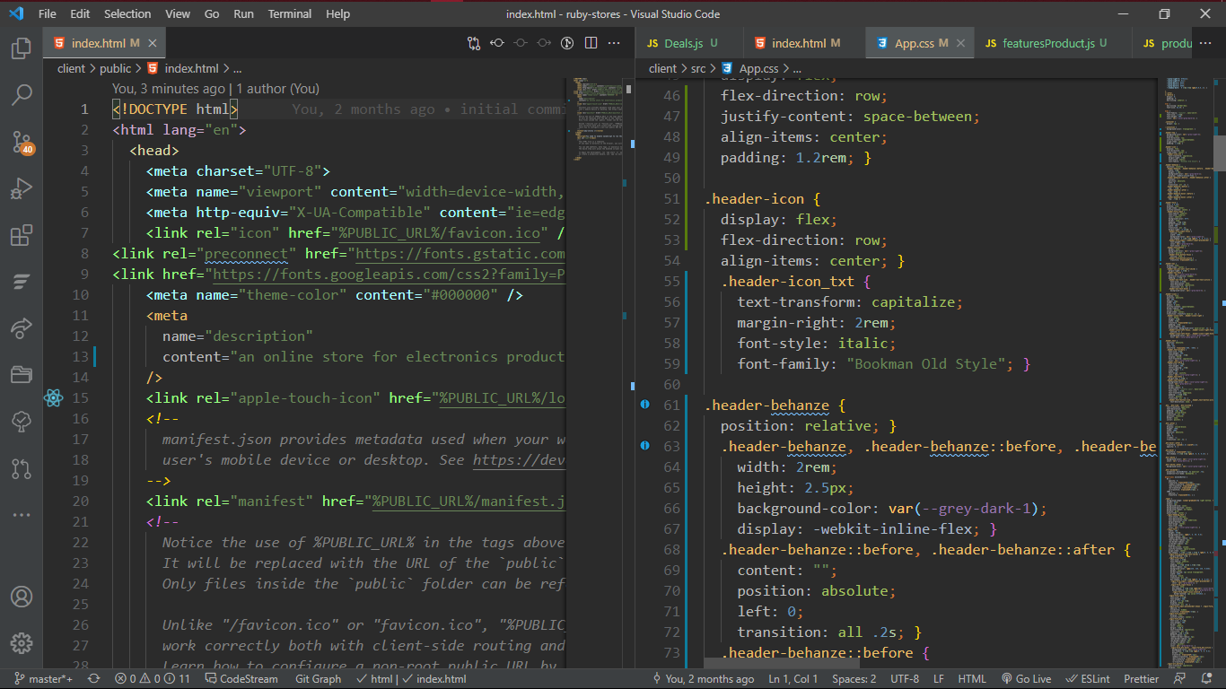

* + 1. **CSS Selector and How They Can be Used.**

CSS selector can be used to find or select HTML element based on the HTML name, attribute, id or class.

1. **Element Selector:** The element selector select element based on the element name.
2. **Id Selector:** The id selector uses the id attribute of an HTML. Element to select a specific element. The id of an element should be unique within the page. So the id selector is used to select one HTML element. E.g <div id=”container” ></div>
3. **Class Selector:** the class selector selects elements with specified class attribute. To select elements with a specified class. With a period character [.] followed by the name of the class e.g .container when HTML looks like <div class=”container”></div>

Image 3

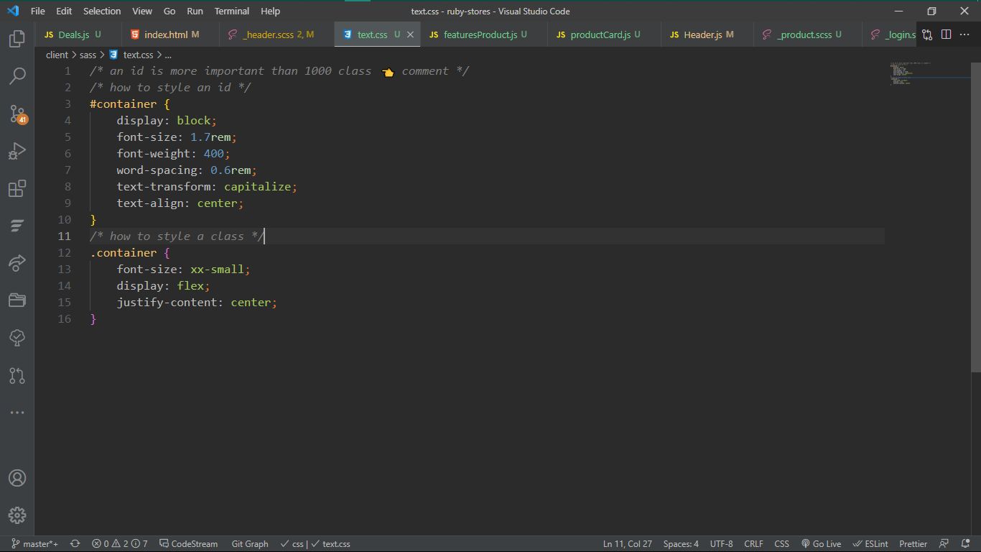

* + 1. **CSS RULES OVERRIDING**

1. Any inline style sheet takes the highest priority, so it will override any rule defined in <style>…</style> tags.
2. Any rule defined in <style> tags will override the rules defined in an external file.
   * 1. **CSS Comments**

To simply put comment inside a style sheet you use /*……………*/, you can use it to document your css code, in similar way you do with java or javascript.

* + 1. **Background and Font of Various HTML Elements**

You can set the following background properties of an element.

1. **Background-color:** is a property used to set the background color of a property.
2. **Background-image property:** is used to set the image properties of a background.
3. **Background-repeat:** is used to control the repetition of an background image.
4. **Background-position:** is used to control position of an image in the background.
5. **Background-attachment:** is used to control the scrolling of an image in the background.

**Font-Properties**

1. **Font-family:** this is used to change the face of a font.
2. **Font-style:** this is used to make a font italic or oblique.
3. **Font-weight:** this is used to increase or decrease the boldness of a font.
4. **Font-size:** this is used to increase or decrease the size of a font.

**Text-decoration**

This demonstrate how to decorate a font in css, the values are none, strikethrough, underline, over line etc.

* + 1. **Properties of Hyper Link**

1. The link signifies unvisited hyperlinks.
2. The link visited signifies visited hyperlink.
3. The link hovered signifies an element that currently has the user mouse on it.
4. The link active signifies an element which the user is currently clicking.

Image 4

Background properties of a css

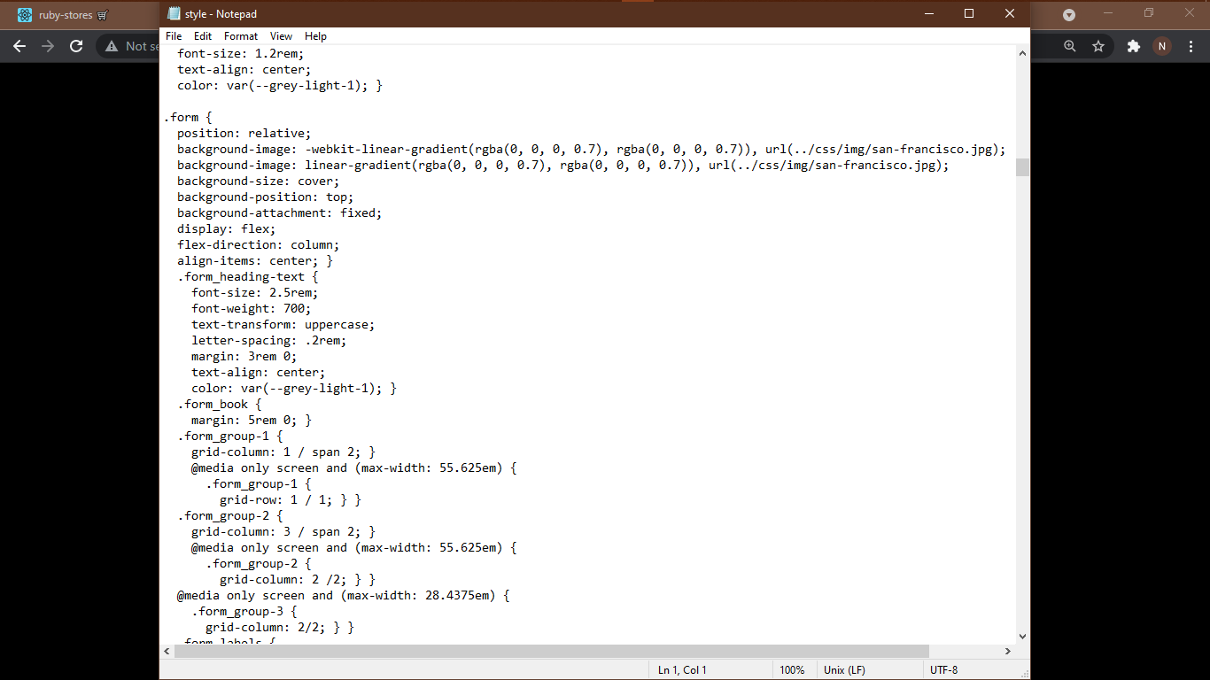

**2.5 Web design using HTML and CSS**

So with this two technologies you can design and create a beautiful and responsive site.

Image 5

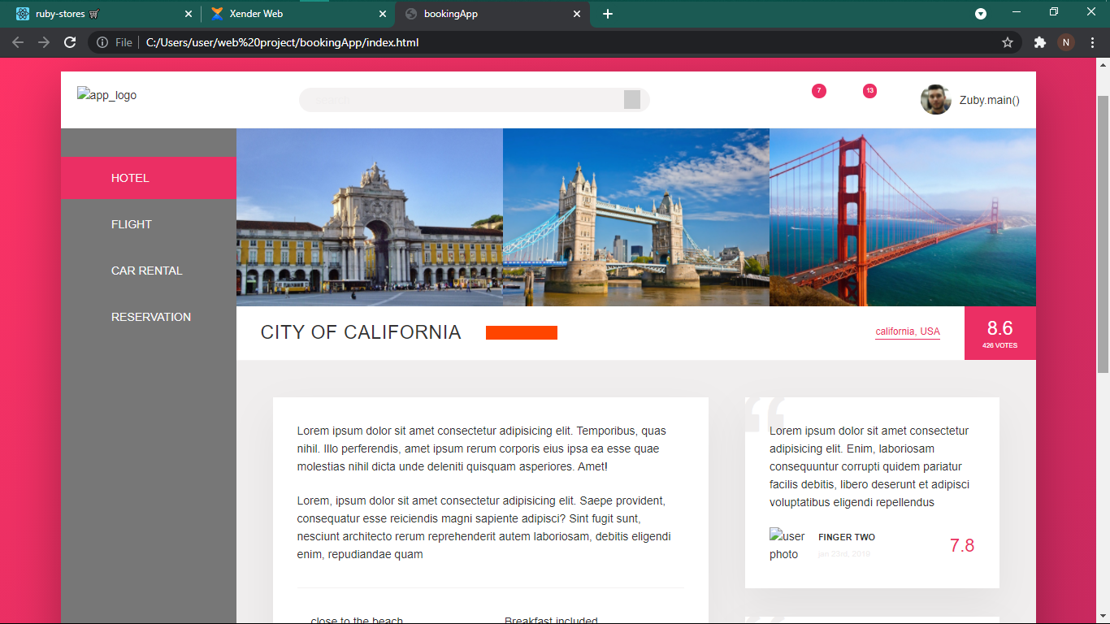

**2.6 Javascript and its Properties**

JavaScript is a programming language. It is lightweight and scripting language which makes it fast to run on the web, it is the most common tool used to create web pages, whose implementation interact with the user and create dynamic pages. It is an interpreted programming language with object oriented capabilities. it was developed by Brenan eich 1995-1996, it is an implementation of ECMA script (European Computers Manufacturers Association). It was also known as livescript later change to javaScript. It is used for writing client-side and nowadays server-side of the web.

**2.6.1 Functions of Javascript.**

1. it is commonly used for writing client-side scripting language with its robust libraries and frameworks, although, javascript can also be used to write the server-side.

2. it is used to improve the ui/ux of our web pages by creating animation and dynamic web pages.

3. it is used for form validation.

**2.6.2 Advantages of using Javascript**

1. Less server interaction: you can validate user input before sending the data off to the server, which means fewer load on the server.
2. Increased interactivity: you can create interfaces that react when a user clicks a button, input on a text field, hover a field etc.
3. Richer interfaces: you can use javascript to include item like drag and drop, slider functionality, and some animation effect on your web page.

One of the major strengths of javascript, it is easy to setup. One can begin with a text editor like vs code, atom, brackets or vim. Since it is interpreted, you don’t need a compiler.

**2.6.2 JavaScript Syntax**

JavaScript syntax refers to a set of rules that determine how the language will be written (by the programmer) and interpreted (by the browser). By learning JavaScript you will become familiar with terms such as variables, functions, statements, operators, data types, objects etc.

**2.6.3 Getting Started with JavaScript**

JavaScript can be implemented using JavaScript statements that are placed within the **<script>... </script>** HTML tags in a web page. The HTML [<script>](https://www.quackit.com/html/tags/html_script_tag.cfm) tags tell the browser to expect a script in between them and it is usually placed at the bottom of <body> tag to increase performance.

**2.6.4 Javascript Variable**

As with any programming language, JavaScript variables are like a container that contains a value — a value that can be changed as required. For example, you could prompt your website users for their first name. When they enter their first name you could store it in a variable called say, firstName. First, you need to declare your variables. You do this using the var, let and const keyword. You can declare one variable at a time or more than one. You can also assign values to the variables at the time you declare them.

Eg var firstName = “stephen”;

Rules for JavaScript Variables

* Can contain any letter of the alphabet and can be followed by the underscore characters and digits.
* No spaces.
* No punctuation characters (eg comma, full stop, etc).
* The first character of a variable name cannot be a digit.
* JavaScript variables' names are case-sensitive. For example *firstName* and *FirstName* are two different variables.

**2.6.5 JavaScript Operator**

JavaScript operators are used to perform an operation. There are different types of operators for different uses.

Below is a listing of JavaScript operators and a brief description of them. Don't worry if you don't understand all of them at this stage.

## Arithmetic Operators

|  |  |
| --- | --- |
| Operator | Description |
| + | Addition |
| - | Subtraction |
| * | Multiplication |
| / | Division |
| % | Modulus (remainder of a division) |
| ++ | Increment |
| -- | Decrement |

## Assignment Operators

|  |  |
| --- | --- |
| Operator | Description |
| = | Assign |
| += | Add and assign. For example, x+=y is the same as x=x+y. |
| -= | Subtract and assign. For example, x-=y is the same as x=x-y. |
| *= | Multiply and assign. For example, x*=y is the same as x=x*y. |
| /= | Divide and assign. For example, x/=y is the same as x=x/y. |
| %= | Modulus and assign. For example, x%=y is the same as x=x%y. |

## Comparison Operators

|  |  |
| --- | --- |
| Operator | Description |
| == | Is equal to |
| === | Is identical (is equal to and is of the same type) |
| != | Is not equal to |
| !== | Is not identical |
| > | Greater than |
| >= | Greater than or equal to |
| < | Less than |
| <= | Less than or equal to |

**2.6.5 Conditional Statement**

When you write code, you will often need to use conditional statements, such as "if" statements. Here's an explanation of the JavaScript If statement.

A *conditional statement* refers to a piece of code that does one thing based on one condition, and another based on another condition. In fact, you could have as many conditions as you like.

JavaScript If statements are an example of conditional statements. With If statements, you can tell the browser to execute a piece of code only *if* a given condition is true.

### **To create a JavaScript If statement**

<="" p="" style="box-sizing: inherit; color: rgb(65, 72, 77); font-family: "Source Sans Pro", "Open Sans", "Helvetica Neue", Helvetica, Arial, sans-serif; font-size: 20px; font-style: normal; font-variant-ligatures: normal; font-variant-caps: normal; font-weight: 300; letter-spacing: normal; orphans: 2; text-align: start; text-indent: 0px; text-transform: none; white-space: normal; widows: 2; word-spacing: 0px; -webkit-text-stroke-width: 0px; text-decoration-thickness: initial; text-decoration-style: initial; text-decoration-color: initial;">

1. Start with the word if
2. Between open and closed brackets, write the actual condition that is being tested (i.e. if something is equal to something else).
3. Between open and closed curly brackets ({}), specify what will happen if the condition is satisfied.

# **JavaScript If Else statement**

The above code is OK if you only want to display something when the condition is true. But what if you want to display something when the condition is not true. For example, what if the variable myColor was equal to, say, Red?

This is where an If Else statement comes in handy. The else part is what we're interested in here. The else is what tells the browser what to do if the condition is not true.

**Switch Statement**

The Switch statement can be used in place of the If statement when you have many possible conditions.

An advantage of using the switch statement is that it uses less code, which is better if you have a lot of conditions that you need to check for.

**2.6.6 Loop Statements**

**While Loop**

In JavaScript (and most other languages), "loops" enable your program to continuously execute a block of code for a given number of times, or while a given condition is true. The JavaScript While loop executes code while a condition is true.

**For Loop**

The JavaScript For loop executes code for a specified number of times.

**2.6.7 Functions**

A function is a self-contained piece of code that returns a value. You can use JavaScript's built-in functions, or create your own.

A function (also known as a method) is a self-contained piece of code that performs a particular "function", then returns a value. You can recognize a function by its format — it's a piece of descriptive text, followed by open and close brackets.

function displayWelcomeMessage() {

...code goes here...

}

The code that goes into a function can be as simple or as complex as you need it to be.

Regardless of the code's complexity inside the function, when you call the function, you don't need to know anything about the code inside. All you need to know is the name of the function, and any arguments that you might need to supply.

For example, take JavaScript's built-in alert() function. You can call that function from within your code without knowing how the function is written. All you need to know is what the function does and how to call it.

**2.7 Frontend using React js**

To give you a gentle introduction, **React** is an open-source JavaScript library used for **frontend** development, which was developed by Facebook. Its component-based library lets you build high-quality user-interfaces for web apps. This library allows you to place HTML code inside JavaScript and it works **with** Virtual DOM

**Why react js**